# Nikibrah Fitness Sync

## About the project

Nikibrah is an extremely successful personal trainer. He uses Google Sheets for his clients.

My plan is to create a simple app to sync MyFitnessPal (fitness/nutrition tracking app) with his Google Sheets at no cost to him and use this as a way to sell additional development to him afterwards. Basically “Hey, look what we can do. You can use this for free, but we can do a lot of other cool stuff.”

## Technical background

Nikibrah writes into the Google Sheet the targets (calories and macros, i.e. carbs/protein/fat) for the week.

Clients use apps like MyFitnessPal to track what they eat and then they write the actual calories and macros into the Google Sheet (so Nikibrah can see if they did what he told them).

The Google Sheet looks similar to this, every client has their personal sheet that is shared with Nikibrah (I just entered some dummy values):

|  |  |  |  |  |  |  |  |  |  |
| --- | --- | --- | --- | --- | --- | --- | --- | --- | --- |
| **Date** | **Kcal** | **Fat** | **Protein** | **Carbs** | **[…]** | **Target kcal** | **Target fat** | **Target protein** | **Target carbs** |
| 1 Jan 2022 | 2300 | 123 | 183 | 112 |  | 2000 | 95 | 230 | 100 |
| 2 Jan 2022 | 1900 | 58 | 240 | 25 |  |  |  |  |  |

It looks like this:

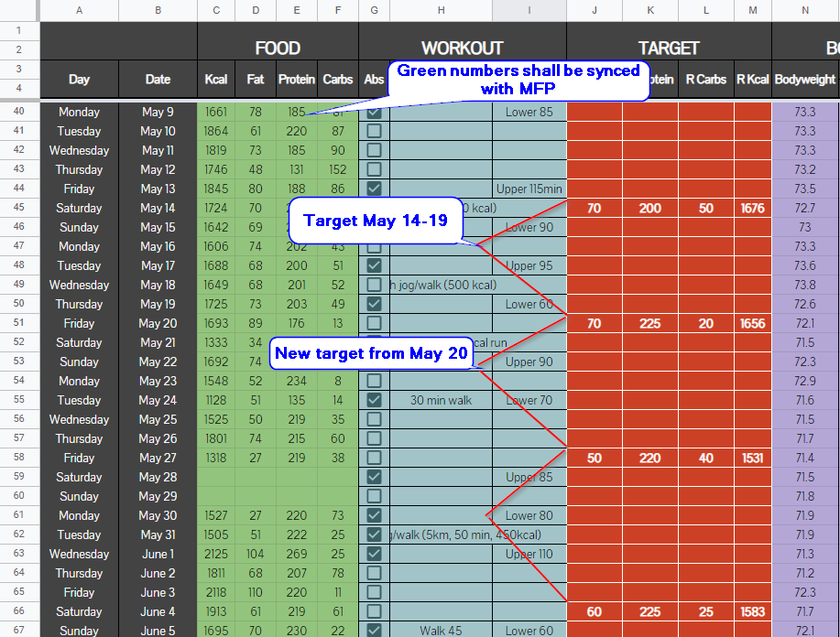

See sample sheet here:  
<https://docs.google.com/spreadsheets/d/18gff0AYASLEFGOL-3z_TWKAo6OajvbOP9kUIOQ5CDZM/edit?usp=sharing>

The target columns are filled by Nikibrah, the columns on the left are filled by the client.

The target values apply to all rows, until new values are added.

What I want is a simple web application (ideally also available as a mobile app) where the user signs in with a federated login for MyFitnessPal and Google, so that the numbers can be synced between MyFitnessPal and Google Sheets.

## Suggested UX

After signing into both Google and MyFitnessPal, the GUI should look like this:

< [ September 1, 2022 ] >

Remaining:

|  |  |
| --- | --- |
| Kcal: | 2000 |
| Protein: | 230 |
| Fat: | 65 |
| Carbs: | 125 |

[Sync] [Sync missing days]

At the top should be the current date with buttons < and > for going to the previous and next day, and when the date is clicked, a datepicker should be shown.

It should then show the remaining values (target - actual).

Below shall be two buttons “Sync” and “Sync missing days”.

“Sync” shall sync the current day, overwriting all values in Google Sheets.

“Sync” shall sync all days where there is data in MyFitnessPal, but no data in Google Sheets. It should not overwrite data where data already exists in Google Sheets.